**Wildfire Management in South Africa: An Assessment using Integrated Fire Management**

**David Flores**

**Desmond Lartey**

**Louis Fleming**

**Dean Ferreira**

Cover photo

Flores, David; Lartey, Desmond; Fleming, Louis; and Dean Ferreira. 2024. Wildfire management in South Africa: An assessment using Integrated Fire Management. Gen. Tech. Rep. RMRS-GTR-xxx. Fort Collins, CO: U.S. Department of Agriculture, Forest Service, Rocky Mountain Research Station. xxx p.

Abstract

This assessment of South African wildland fire management is part of a broader effort from the International Programs Office of the US Forest Service to assess the wildland fire situation across Africa. The assessment was guided by an Integrated Fire Management approach, which incorporates a holistic understanding of fire on the landscape and the many trade-offs of management actions. This assessment is based on a survey administered from June – July 2023 and captures the diverse perspectives of 108 survey respondents. Findings from this assessment reveal the following: 1) a perception that wildland fires have significant unwanted effects in their communities; 2) arson is identified as the leading cause of human-originated wildfires; 3) respondents have mixed perspectives on having enough personnel to deal with wildland fires depending on province; 4) most respondents perceive that the incident command system is used in their community; and 5) perceptions toward restoration guidelines for ecosystems affected by wildland fires are mixed, and regional data suggest potential disparities in recovery efforts.

**Keywords:** South Africa, Integrated Fire Management, wildfire, bushfire, firefighters

# Authors

**David Flores** is a Research Social Scientist with the Human Dimensions Program of the U.S. Department of Agriculture (USDA) Forest Service, Rocky Mountain Research Station in Fort Collins, Colorado. His research focuses on the social and cultural characteristics of decision making and natural resource management. He directs the Social Science Research Group (SSRG) for wildland fire at the Human Dimensions program, RMRS.

**Desmond Lartey** is a Graduate Researcher with the International School for Social and Business Studies. He is also currently leading mapping and modelling tasks for the DesirMED project under the European Mission on Climate Adaptation.

**Louis Fleming** is a Fire Program Specialist with the USDA Forest Service, International Programs. He has an M.S. in Forestry from the University of Montana.

**Dean Ferreira** is the Managing Director of NCC Group of Companies in South Africa. He has a degree in nature conservation and is an integrated wildfire management specialist with 40 years of experience in the field.

# Acknowledgments

This study would not have been possible without the participation of South African wildland fire managers and Forest Service International Programs who shared their perspectives of wildland fire management. We thank Dr. Lauren Redmore and Dr. Chris Armatas of the USDA Forest Service, Rocky Mountain Research Station, Aldo Leopold Wilderness Research Institute, for their feedback and suggestions in developing questions for this and other lines of inquiry. We also thank the following reviewers for their insightful comments on earlier drafts of this report:

# Executive Summary

The general purpose of this assessment is to examine the state of contemporary perceptions of wildland fire managers in South Africa. Our investigation proceeds not through an evaluation of current policies and practices. Instead, we provide the reader access to the perspectives of South African wildland fire managers working in the field. Our goal is to provide South African wildfire managers and the Forest Service, U.S. Department of Agriculture (and anyone else), with a comprehensive depiction of wildland fire management using the framework of Integrated Fire Management. Learning about the perspectives of fire managers doing the work of wildland fire management opens meaningful lines of research and practice that may not otherwise be apparent without a grounded assessment of programmatic gaps and needs. The assessment was administered virtually from June – July 2023 and includes 108 survey respondents. Results are based on the five R’s of Integrated Fire Management (review, risk reduction, readiness, response, and recovery) for development, administration, analysis, and production of assessment results. Findings from this assessment reveal the following: 1) a perception that wildland fires have significant unwanted effects in their communities; 2) arson is identified as the leading cause of human-originated wildfires; 3) respondents have mixed perspectives on having enough personnel to deal with wildland fires depending on province; 4) most respondents perceive that the incident command system is used in their community; and 5) perceptions toward restoration guidelines for ecosystems affected by wildland fires are mixed, and regional data suggest potential disparities in recovery efforts. The authors suggest follow-up studies using qualitative data collection to capture greater context and the meanings behind assessment responses, as well as for revision of assessment questions.

# CONTENTS

Abstract ii

Authors iii

Acknowledgments iv

Executive Summary v

CONTENTS vi

Introduction 1

Purpose of this Study 1

Background 1

Methodology 4

Assessment Design and Structure 4

Demographic Information 8

Approach to Data Processing 9

Analysis Strategy 12

Findings 16

Summary of Results 23

Review 23

Risk Reduction 24

Readiness 24

Response 24

Recovery 25

Opportunities for Further Investigation 26

Assessment Limitations 27

Conclusion .27

References 29

# Introduction

## Purpose of this Study

The purpose of this study is to provide an assessment of wildland fire management in South Africa, specifically within the management framework of Integrated Fire Management (IFM). We proceed with this assessment not through an evaluation of current policies or theoretical frameworks, but instead by providing the reader access to the perspectives of wildland fire managers working in South Africa. Our goal is to provide the Forest Service, U.S. Department of Agriculture, and South African fire managers (and anyone else) with a comprehensive assessment of wildland fire management in South Africa. Learning about the perspectives of wildland fire managers engaged in fire management opens meaningful lines of research and practice that may not otherwise be apparent without a grounded assessment of programmatic gaps and needs (Flores et al. 2024). This analysis also holds the possibility of adding to underrepresented academic research on wildland fire in Africa despite the African continent accounting for one of the most widely burned regions in the world (Lin et al. 2024).

## Background

Wildland fire related programming is in high demand throughout the world, and Africa is no exception. Africa has the highest portion of fire prone ecosystems in the world, and climate change is creating warmer, drier conditions (Jones et al. 2022). When measured by satellite, annual burned area in Africa accounts for approximately 67% of the global total; impacts are more difficult to measure but run the gamut, both positive and negative (Jolly et al. 2015). At the same time, while the African continent accounts for most of the global burned area (along with Siberia), most wildland fire studies are being conducted in countries with higher levels of development, with the western United States accounting for the majority of wildland fire research publications (Lin et al. 2024). In South Africa, people have used fire to manipulate the landscape for thousands of years and ecosystems have coevolved with fire, resulting in highly resilient fire-adapted landscapes (Rego et al. 2021). At the same time, fire suppression policies, urban development, and changes in extreme weather-related events have increased the complexity of fire management and the role of people living with fire (Dombeck et al. 2004). In South Africa, this is the case across both veld regions (open, uncultivated country or grassland), as well as in the growing wildland urban interface (van Wilgen et al. 2014).

To fully consider the ecological, social, cultural, and economic context in which wildfires occur, we utilize IFM. IFM is a framework that acknowledges increased wildfire complexity by integrating ecology, society, and fire management technologies to address wildland fire beginning with community-based fire management as the initial level of integration (Moore 2019; Rego et al. 2021). Community based fire management is the initial building block for establishing a resilient IFM framework through districts, states/provinces, and national levels across developing and developed countries for effectively living with wildland fire (Moore 2019). IFM recognizes that fire is a natural and necessary ecological process in many ecosystems, playing a crucial role in maintaining biodiversity, nutrient cycling, and overall ecosystem health (Wollstein et al. 2022). However, it also acknowledges that fire can pose risks to human life, property, and livelihoods (Lambrechts et al. 2023). IFM emphasizes the integration of various strategies and tools to effectively manage fire in a way that minimizes negative impacts while promoting positive impacts, such as ecological health and community safety. This includes acknowledging fire’s positive and negative impacts from ecological, economic, and socio-cultural perspectives and the trade-offs that inevitably result from decisions and actions. Moore (2019) defines the tool for systematically developing an IFM framework as the five R’s of IFM:

1. Review: Analysis of the fire issue and identification of options for positive change;
2. Risk Reduction: Prevention and focusing resources on the underlying causes of fires;
3. Readiness: Preparing to fight fires;
4. Response: Ensuring appropriate responses to unwanted damaging fires; and
5. Recovery: Community welfare, repairing infrastructure, and restoration of fire-damaged landscapes, rest, recovery, and maintenance repair.

The five R’s of IFM begin from the perspective that fire is a catalyst for promoting biological diversity and healthy ecosystems. To improve wildland fire outcomes requires a risk mitigation management approach that moves away from a reactive model of fire suppression and toward a proactive process that accommodates the complex social and ecological context of wildfire (Wollstein et al. 2022). Rather than focusing on full suppression of wildfire for the purpose of minimizing area burned, IFM uses the tools of fire suppression and fire itself to further vegetation and land management goals (see Figure 1).

INSERT Figure 1 HERE

IFM includes and goes well beyond fire suppression to maximize the net benefits of fire and further the strategic goals of fire management for sustainable landscape management.

The following is an assessment of perspectives of South African wildland fire managers on current practices and needs through the lens of IFM across the nine South African provinces of Eastern Cape, Free State, Gauteng, KwaZulu-Natal, Limpopo, Mpumalanga, Northern Cape, North West, and Western Cape, with the highest participation coming from the province of Western Cape. The assessment is the beginning of a broader effort from the US Forest Service International Programs to identify potential opportunities to support South African wildland fire managers in strengthening IFM capacity across the nine South African provinces.

After reporting on the methodology used for this assessment, we present the perspectives of South African wildland fire managers within the framework of the five R’s of IFM. We then discuss the implications of this assessment, management implications, limitations, and opportunities for further investigation.

# Methodology

The five R’s of IFM served as the management framework to develop the assessment administered to South African wildland fire managers. Surveys were administered virtually from June – July 2023 resulting in 108 total survey respondents. In the following sections, we outline the data collection process by discussing assessment design and structure, approach to data processing, merging of demographic and categorized data, analysis strategy, and using the web-based application Streamlit for exploration and visualization.

## Assessment Design and Structure

The data for this assessment were collected virtually and focused on various aspects of wildland fire management in South Africa. The primary aim of the assessment was to explore respondents' perceptions, experiences, and knowledge concerning wildland fire incidents, response strategies, recovery efforts, and readiness measures. Additionally, we collected demographic data to contextualize responses across different societal and occupational groups. Please note that the data are not open to the public due to confidentiality of personal data. Please contact the Forest Service International Programs and the authors of this GTR for additional information on data collection.

The assessment included a mix of open-ended and multiple-choice questions to facilitate both statistical analysis and in-depth qualitative insights. Open-ended questions allowed for detailed, narrative responses on specific topics, while multiple-choice questions provided structured, comparable data. This mixed-methods approach enabled us to capture a comprehensive view of respondents' experiences and perceptions related to wildland fire management.

Below is a detailed breakdown of the key areas covered using the five R’s of IFM:

### Review: Analysis of the Fire Issue and Identification of Options for Positive Change

This section of the assessment focused on understanding the broader impacts of wildland fires and analyzing specific aspects of fire management strategies in South Africa. Questions in this section aimed to capture respondents' insights on:

* The negative impacts of wildland fires: Respondents were asked to identify the three most unwanted effects of wildfires, with response options ranged from loss of life to destruction of biodiversity and economic assets.
* Positive outcomes: The assessment inquired about the three most desirable effects of prescribed burns or fire management strategies, with response options from which respondents could choose focused on ecological benefits such as species diversity or land regeneration.
* Success factors and areas for improvement: Respondents provided their views on the most successful aspects of fire management in South Africa and identified areas that need improvement. This included both managerial practices and ecological outcomes.
* Knowledge sharing: The assessment asked for aspects of fire management in South Africa that could be shared with other African nations, encouraging a comparative analysis of management practices across regions.

### Risk Reduction: Prevention and Focusing Resources on the Underlying Causes of Fires

The risk reduction category of the assessment explored respondents’ perspectives on the causes and prevention of wildfires. This section aimed to identify:

* Causes of wildfires: Respondents were asked to specify the top two causes of human-originated wildfires, with options such as arson, agricultural burns, or negligent use of fire.
* Preventive measures: Open-ended questions inquired about measures that can mitigate the risk of wildfires. Respondents shared their thoughts on firebreaks, community awareness programs, and policy measures designed to reduce fire risks.
* Intentional fires: The assessment sought respondents' opinions on the potential motivations behind intentional fires (ignitors), exploring underlying reasons such as land clearing, cultural practices, or malicious intent.

### Readiness: Preparing to Fight Fires

This section evaluated the level of preparedness within communities and organizations to respond to wildland fires. Respondents provided information on:

* Training programs: The assessment inquired about the existence and efficacy of national training programs or certification processes for fire management personnel. Respondents shared their experiences or knowledge about the availability and quality of such programs.
* Sufficiency of personnel: Questions were aimed at assessing whether there were enough trained professionals to handle wildland fires in the respondents' communities. This section provided insight into the operational readiness of local fire management agencies.
* ~~Professional training: The respondents also discussed whether wildland fire suppression brigades were adequately trained and equipped to handle fires effectively. This involved gauging the overall level of skill and readiness within different regions.~~
* Perceptions of brigade readiness were assessed through rating-scale questions and optional text responses, offering insight into whether fire suppression teams were seen as adequately trained and equipped across regions.

### Response: Ensuring Appropriate Responses to Unwanted Damaging Fires

The response section delved into the operational capacity of communities and organizations when dealing with fire incidents. This section captured information on:

* Incident command systems: Respondents were asked about the utilization of formal Incident Command Systems (ICS) during fire incidents in their communities. ICS is a standardized, on-scene, all-hazards incident management approach, and its presence was an indicator of organized fire management.
* Equipment and resources: The assessment sought to capture the types of firefighting equipment and resources available in the community, such as fire trucks, water tenders, helicopters, or personal protective equipment. Respondents indicated whether such resources were government provided or locally sourced.
* Operational challenges: Respondents also identified gaps in equipment, personnel protection, and tactical resources that may hinder the effectiveness of fire response operations in their areas.

### Recovery: Community Welfare, Repairing Infrastructure, and Restoration of Fire-Damaged Landscapes

This category focused on the strategies and support systems available for community and ecosystem recovery after wildland fire events. Key subsections included:

* Community support programs: Respondents were asked whether there were formal programs in place to assist communities in recovering from the effects of damaging wildfires. This included financial aid, mental health support, and rebuilding efforts.
* Ecosystem restoration: Respondents were asked about the availability of restoration guidelines or initiatives aimed at rehabilitating fire-affected ecosystems. Respondents shared their knowledge about biodiversity recovery efforts and whether these efforts adhered to standardized environmental restoration practices.

## Demographic Information

In addition to the thematic questions about IFM, we also collected detailed demographic data to enrich the analysis. This information helped profile the respondents while providing context to their responses. The demographic data collected included:

* Gender and race: This allowed for an analysis of how experiences and opinions varied across different demographic groups.
* Geographical location: Respondents were asked about the province and district in which they primarily resided, providing insight into regional differences in fire management experiences and challenges.
* Occupation: Respondents provided details about their professional background, particularly if they worked in fire management, environmental conservation, or related fields.
* ~~Demography: The collected demographic data were synthesized into a "Demography" field, which combined race, gender, and location to allow for a quick and comprehensive view of the respondent’s background.~~
* To streamline analysis and enable group comparisons, demographic variables like race, gender, and location were synthesized into a single “Demography” field. This integration allowed for efficient comparison, and cross-tabulation of respondents' backgrounds across the different levels of analysis.

The assessment design facilitated comprehensive data collection on various aspects of wildland fire management. By structuring questions around the five R’s of IFM, we gathered both operational and ecological views on fire management in South Africa. Including demographic details enabled analysis of how fire management experiences and challenges differed across societal groups and regions.

**Table 1**

|  |  |
| --- | --- |
| **Category** | **Response** |
| **Gender** |  |
| Male | 80 |
| Female | 13 |
| Non-response | 15 |
| **Occupation (multiple responses)** |  |
| Wildland Firefighter | 40 |
| Nature Conservator | 39 |
| Firefighter (general) | 18 |
| Consultant | 17 |
| Volunteer Firefighter | 15 |
| **Province** |  |
| Western Cape | 81 |
| Mpumalanga | 6 |
| Eastern Cape | 4 |
| KwaZulu Natal | 4 |
| North West | 4 |
| Gauteng | 3 |
| Limpopo | 2 |
| Free State | 1 |
| Northern Cape | 1 |
| Non-responses | 2 |
| **Race** |  |
| White | 65 (Combined "White" & "Caucasian") |
| Black African | 2 |
| Coloured | 1 |
| European | 3 |
| White African | 1 |
| Other | 1 |
| Non-response | 32 |

Note* Categories were self-reported, with some responses merged for clarity. Respondents chose only one category. Of 108 respondents, the largest group was from Western Cape (n = 81), followed by Mpumalanga (n = 6), Eastern Cape (n = 4), KwaZulu-Natal (n = 4), North West (n = 4), Gauteng (n = 3), Limpopo (n = 2), Free State (n = 1), and Northern Cape (n = 1). Two did not report their province.

## Approach to Data Processing

### Step 1: Initial Cleaning

After data collection, the data were exported into a structured spreadsheet, containing respondent demographics, answers, and metadata, such as response start and end dates. The initial processing step involved cleaning the raw dataset to ensure usability, removing irrelevant columns and handling missing or inconsistent values. Columns such as "IP Address" and optional contact information were excluded to retain focus on core responses. Incomplete entries were either discarded or filled with placeholder values to maintain data integrity. The cleaned dataset, now standardized, included demographic information and responses for further analysis.

### Step 2: Categorization of Responses

The second step of the process involved categorizing the responses into predefined categories based on each subject. Questions were divided into six primary categories: *review, risk reduction, readiness, response*, *recovery*, and *miscellaneous*. There was also an *additional insight* category for questions that fell outside of the predefined categories to allow for new themes to emerge.

The categorization process was guided by a keyword-based mapping strategy. Each question was analyzed against a predefined set of keywords associated with the different categories. For example, questions involving fire management personnel, equipment, and firefighting tactics were categorized under *response*, while questions related to training programs or preparedness efforts were classified under *readiness*. This mapping required a deep understanding of the assessment structure and content.

This step also involved developing an algorithm to detect key phrases within the questions. The algorithm worked by scanning each question, matching it against a list of predefined keywords, and assigning the appropriate category based on the content of the question. This categorization allowed the responses to be organized by theme, making it easier to analyze the data within each respective field. The output of this step was a newly categorized dataset that included the respondent ID, the category of the question, the question itself, and the corresponding response.

### Step 3: Merging Demographic and Categorized Data

The third and final step involved integrating the demographic information of each respondent with the categorized responses. The demographic information included fields such as race, gender, province, and occupation. The goal was to enrich the categorized data by including these demographic details, allowing for a more comprehensive analysis of the responses.

To achieve this, the cleaned dataset (which contained demographic information) was merged with the categorized dataset (which contained categorized responses). This merge was based on the respondent ID, ensuring that each response was linked to the corresponding respondent’s demographic data. A key challenge in this step was ensuring that the demographic fields, such as race, gender, province, and occupation, were appropriately aligned with the responses. The solution was to harmonize these fields, ensuring consistent formatting and handling any missing data carefully. In cases where respondents did not provide certain demographic details, placeholder values were used to maintain the structure of the data.

To further enhance the analysis, a new field, *demography*, was created by concatenating the race, gender, province, and occupation information into a single field. This allowed for a quick view of the respondent's demographic profile alongside their responses. The final dataset consisted of the following columns: *respondent ID*, *category*, *question*, *response*, *race*, *gender*, *province*, *occupation*, and *demography*. This structure enabled detailed analysis across multiple dimensions, such as understanding how responses varied by demographic group or region.

## Analysis Strategy

An analysis strategy was designed to extract insights from responses by focusing on the relationships between respondents’ demographic information and their responses across different categories of questions. This section details the methodological approach used for the analysis, focusing on the comparative and correlation-based frameworks applied to the dataset.

### Approach to Comparative Analysis

The comparative analysis aims to understand how different demographic groups responded to various questions. The focus is on identifying patterns and trends across demographic fields such as gender, race, province, and occupation, and how these groups perceive and interact with the topic of wildland fire management.

The comparative analysis begins by filtering the dataset to isolate responses to a particular question. Once the relevant data are extracted, the responses are further grouped based on a selected demographic, allowing for the comparison of answers across different respondent profiles. This helps to highlight the influence of factors such as location or occupation on attitudes toward wildland fire management.

For example, if analyzing responses to the question, “What are the top two causes of human-originated wildfires?” the data would be grouped by the selected demographic (e.g., province). The responses would then be compared across provinces to reveal whether geographic location has a significant impact on perceptions regarding wildfire causes. The results of these analyses are visually represented using different types of charts, such as bar charts or pie charts, depending on the data structure.

### ~~Approach to Correlation Analysis~~

~~Correlation analysis, in contrast to comparative analysis, aims to uncover potential relationships between responses to different questions. This analysis is valuable for identifying underlying patterns between different aspects of wildland fire management as perceived by the respondents.~~

~~The correlation process begins by selecting two questions that are hypothesized to have some form of interdependency. For instance, responses to a question about the sufficiency of firefighting equipment may be correlated with responses regarding the preparedness of fire brigades. The responses to both questions are merged, allowing for the examination of how often certain responses to one question co-occur with specific responses to another.~~

~~Once the data are merged, a contingency table (or crosstab) is constructed to cross-classify the responses to the two questions. The strength of the relationship between the responses is visually represented using heatmaps. The correlation analysis provides insights into how different aspects of wildland fire management are interlinked in the perceptions of the respondents. For example, it can reveal whether respondents who believe that equipment is inadequate are also more likely to view community preparedness as insufficient. This type of analysis offers a more nuanced understanding of the challenges and opportunities in fire management.~~

### ~~Integration of Demographic Data in Correlation Analysis~~

~~In the comparative analysis, demographic information acts as the key factor for segmenting the data. This segmentation allows for comparisons between different groups and helps identify how personal and professional backgrounds influence perspectives on wildland fire management. For example, examining responses from individuals in different occupations, such as firefighters versus foresters, reveals how roles within the fire management ecosystem shape perceptions. In correlation analysis, demographic data does not directly affect the calculation of correlations but helps in understanding the broader context of the relationships between different responses.~~

### ~~Response Distribution and Top N Analysis~~

~~There were more than 7,000 records of data. To manage the large dataset and focus on the most significant findings, the analysis includes a top N approach. This involves selecting the most frequent responses for analysis, which ensures that the most impactful or commonly held views are prioritized in the analysis. The function selects the top responses based on total mentions across all demographic factors and then filters for visualization accordingly. The top N responses provide a clearer picture of general sentiment without outliers or less common opinions. For example, in a question where respondents are asked about the most frequent causes of wildfires, only the top 20 responses might be visualized, allowing for more focused insights on the primary drivers of wildfires as perceived by most respondents.~~

### ~~Using Streamlit for Exploration and Visualization~~

~~The findings were analyzed through a web-based application named Streamlit to enable interactive exploration and visualization. Streamlit's flexible and user-friendly platform allows users to dynamically filter and analyze data by selecting categories, questions, and demographic attributes via an intuitive sidebar. This real time engagement facilitates quick insights based on specific interests or concerns for stakeholders, researchers, and decision makers.~~

~~The app supports comparative or correlation analyses across various questions, offering tailored visualizations such as bar charts, pie charts, heatmaps, and line charts. Users can choose the type of analysis and chart to best represent the relationships and trends they wish to explore. This interactivity is crucial for presenting complex datasets like the South Africa Wildland Fire assessment in an accessible manner, enabling users to gain actionable insights without needing advanced technical expertise. Users can focus on specific questions or examine relationships between multiple questions. The option to switch between comparative and correlation analysis ensures a wide range of insights aligned with research goals.~~

~~This flexibility supports the broader aim of understanding respondent perceptions and deriving actionable insights to inform policy and operational strategies in wildland fire management. The data driven approach helps stakeholders identify key areas for improvement, assess existing programs' efficacy, and prioritize future research and interventions. The following link can be used to develop your own customized Streamlit app for exploring and visualizing data:~~ [~~https://github.com/~~](https://github.com/)~~. This site provides a guide that will assist users in fully leveraging the interactive features of the app to perform their own customized analysis.~~

# Findings

The assessment revealed some important insights into perceptions and experiences of wildland fire management across South Africa, categorized into five thematic areas: *review, risk reduction, readiness, response, and recovery.* Examination of these areas showed notable regional, race, and gender-based differences in experiences and perceptions related to wildland fires.

### Review: Analysis of the Fire Issue and Identification of Options for Positive Change

~~Our findings showed that 58% of respondents either "somewhat agree" or "strongly agree" that wildland fires harm their communities, indicating the acknowledgment of these detrimental effects (see fig. 2a and 2b). Notably, heightened concern was observed in the Western Cape province, where 11 out of 19 participants "strongly agree" about the severe negative impacts of wildland fires.~~

Our findings showed that 58% of respondents either "somewhat agree" or "strongly agree" that wildland fires harm their communities (see fig. 2a and 2b). Heightened concern was observed in the Western Cape, where 73 out of 81 participants "strongly agree" about the severe negative impacts of wildland fires. Despite high representation from the Western Cape (n = 81), only a subset provided valid open-text responses on unwanted effects. The top three effects based on coded responses were: Loss of life, Property damage, and Biodiversity loss. Less frequently mentioned themes such as air pollution, infrastructure damage, and fire regime compromise were grouped under “Other Effects.” Table 2 below presents the provincial distribution of the most frequently cited effects:

Table 2

|  |  |  |  |  |  |
| --- | --- | --- | --- | --- | --- |
| Province | Loss of life | Property Damage | Biodiversity Loss | Other Effects | Total Responses |
| Western Cape | 6 | 3 | 2 | 3 | 14 |
| Mpumalanga | 2 | 0 | 0 | 0 | 2 |
| Eastern Cape | 2 | 0 | 0 | 0 | 2 |
| Others (prov) | 8 | 7 | 5 | 8 | 28 |

**~~Figure 2b~~**

At the national level, the responses from all provinces were pooled and categorized by theme. Table 3 presents a frequency-based summary of all coded mentions across the country, totaling 56 mentions. The top three most frequently reported effects were Loss of life (32%), Property damage (18%), and Biodiversity loss (12%).

Table 3

|  |  |  |
| --- | --- | --- |
| Unwanted Effect | Frequency | % of Total Mentions |
| Loss of life | 18 | 32% |
| Property damage | 10 | 18% |
| Biodiversity loss | 7 | 12% |
| Damage to infrastructure | 5 | 9% |
| Compromise of fire regime in watersheds | 3 | 5% |
| Air pollution | 2 | 4% |
| Others (listed in supplement) | 11 | 20% |

**Note:** Frequencies represent mentions, not unique respondents. A respondent could contribute multiple mentions across categories, as each person could list up to three unwanted effects. "Other Effects" includes less frequently cited themes such as economic loss, destruction of grazing lands, tourism impacts, or soil degradation.

~~Demographically, 46% of Black respondents expressed concern about the adverse effects of wildland fires. Additionally, male respondents were more likely than females to "strongly agree" about the negative impacts of wildfires.~~

Of the two respondents identifying as Black African, one expressed concern about wildland fire effects. Given the small number in this group, no meaningful statistical comparison can be drawn across racial categories. Among gender groups, 80 male and 13 female respondents participated. A higher proportion of males than females selected 'strongly agree' regarding wildfire negative impacts.

### Risk Reduction: Prevention and Focusing Resources on the Underlying Causes of Fires

~~Our analysis identified arson as the leading cause of human originated wildfires, cited by 17 respondents, followed by negligence, mentioned by seven respondents. When queried about intentional fires, 41 respondents pointed to arson as the main motive, while grazing and fuel management were also significant, with 16 and 11 mentions, respectively (see fig. 3).~~

Respondents listed perceived causes of human-originated wildland fires. 122 coded mentions were extracted from open-text responses and grouped thematically.

The most commonly cited cause was arson, appearing in general and intentional-use contexts. Combined, arson was mentioned 58 times, making it the most frequently reported origin of wildfires. This was followed by grazing-related fires (n = 16), fuel management practices (n = 11), and negligence (n = 7). Other causes included civil unrest (n = 9), invasive alien vegetation management (n = 1), and various sources (n = 20), such as powerlines, campfires, and religious/spiritual burning rituals. The complete summary is presented in Table 4.

Table 4. Grouped Frequencies of Perceived Human-Originated Causes of Wildland Fires

| **Cause of Fire (Grouped Category)** | **Frequency** | **Data Source** |
| --- | --- | --- |
| Arson (all cases merged) | 58 | Causes + Intentional fire motives |
| Grazing (intentional) | 16 | Intentional fire motives |
| Fuel Management (intentional) | 11 | Intentional fire motives |
| Negligence (all variations) | 7 | Direct cause category |
| Unrest (intentional) | 9 | Intentional fire motives |
| Invasive Alien Management | 1 | Intentional fire motives |
| Hunting (intentional) | 0 | Intentional fire motives |
| Other (e.g., powerlines, campfires, unknown) | 20 | Free-text and miscellaneous entries |

**~~Figure 3~~**

~~Female respondents identified arson as a primary concern for intentionally set fires, reflecting gender specific safety concerns or experiences.~~

### Readiness: Preparing to Fight Fires

~~When evaluating the readiness of personnel to manage wildland fires, assessment results indicated mixed perceptions. While 29% of respondents "somewhat agree" that there are sufficient personnel to deal with wildland fires, 23% "strongly disagree," highlighting a significant divide in perceived preparedness. Regional analysis showed that the Western Cape once again stands out, with seven out of 19 respondents "strongly disagreeing" about personnel readiness.~~

In the Western Cape, only 19 respondents answered this particular question. Of these, 7 respondents (37%) selected "Strongly disagree" with the statement that there are enough trained personnel to handle wildland fires. The small sample size of respondents for this question should be interpreted cautiously.

**~~Figure 4~~**

**Figure 1**

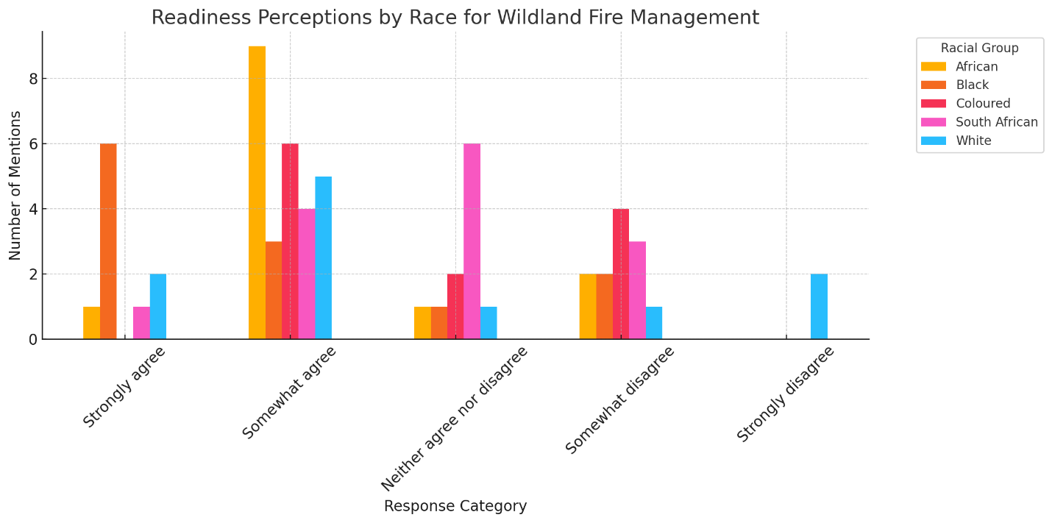

Regarding brigade training, we found that 42 respondents "somewhat agree" and 33 "strongly agree" that wildland fire suppression brigades are professionally trained and equipped. This positive outlook on brigade readiness was more prevalent among Black and Coloured respondents, who were more likely to express confidence in the brigade’s preparedness compared to White respondents (see fig. 1).

### Response: Ensuring Appropriate Responses to Unwanted Damaging Fires

Our findings on the response capabilities to wildfires showed that a substantial number of respondents agreed, 36 "strongly agree" and 36 "somewhat agree," that a formal ICS is utilized in their communities. However, we also noted regional disparities, with respondents in the Western Cape showing stronger agreement compared to mixed perceptions in Eastern Cape and Gauteng.

Despite the overall agreement, perceptions varied significantly across provinces (see Figure 2). Respondents from the Western Cape reported the highest level of agreement, with the majority selecting *"Strongly agree"* or *"Somewhat agree"*. In contrast, provinces such as Eastern Cape and Gauteng displayed more varied responses, including mentions of *"Somewhat disagree"*, and *"Neither agree nor disagree"*.

**~~Figure 5a~~**

**Figure 2**

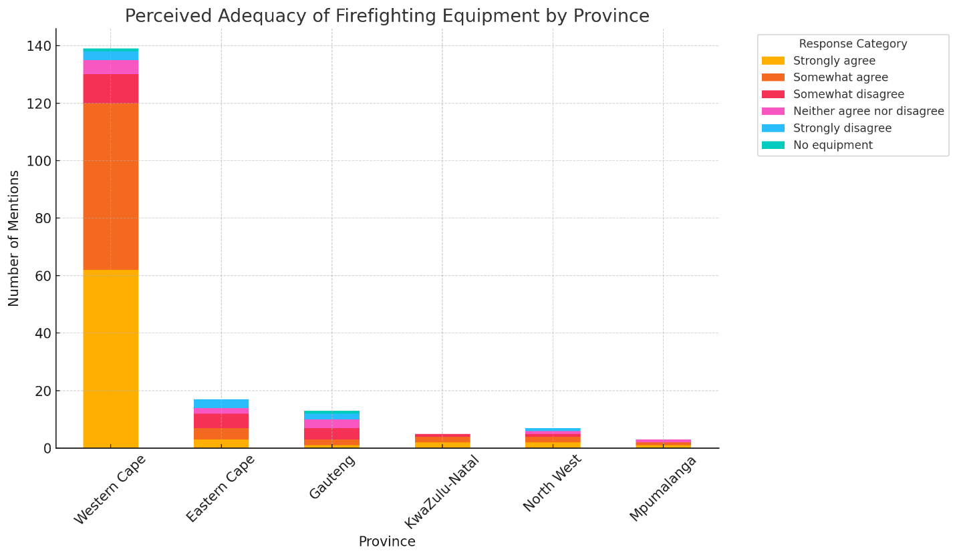

**~~Figure 5b~~**

**Figure 2**: *Perceived adequacy of firefighting equipment by province. Responses are shown by category and stacked to indicate the level of agreement. The Western Cape had the most consistently positive responses, while other provinces exhibited mixed perceptions.*

In terms of equipment provision, 75 respondents either "strongly agree" or "somewhat agree" that firefighters are equipped. However, 17 respondents expressed concerns about the quality or availability of equipment. Gender based analysis revealed that female respondents were slightly more optimistic about the provision of equipment compared to males.

### Recovery: Community Welfare, Repairing Infrastructure, and Restoration of Fire-Damaged Landscapes

~~When it comes to recovery efforts following wildland fires, we found that 42 respondents either "somewhat agree" or "strongly agree" that there are restoration guidelines in place for ecosystems affected by wildland fires. However, a substantial proportion of respondents (32) expressed concerns, either "somewhat disagreeing" or "strongly disagreeing."~~

When asked about recovery efforts following wildland fires, 74 respondents selected one of four agreement options. Of these, 42 expressed agreement that restoration guidelines were in place, with 24 selecting "somewhat agree" and 18 "strongly agree." In contrast, 32 respondents expressed concern: 20 selected "somewhat disagree," and 12 "strongly disagree."

The remaining respondents selected "neither agree nor disagree" or did not respond. This could indicate uncertainty or lack of familiarity with recovery programs..

**~~Figure 5c~~**

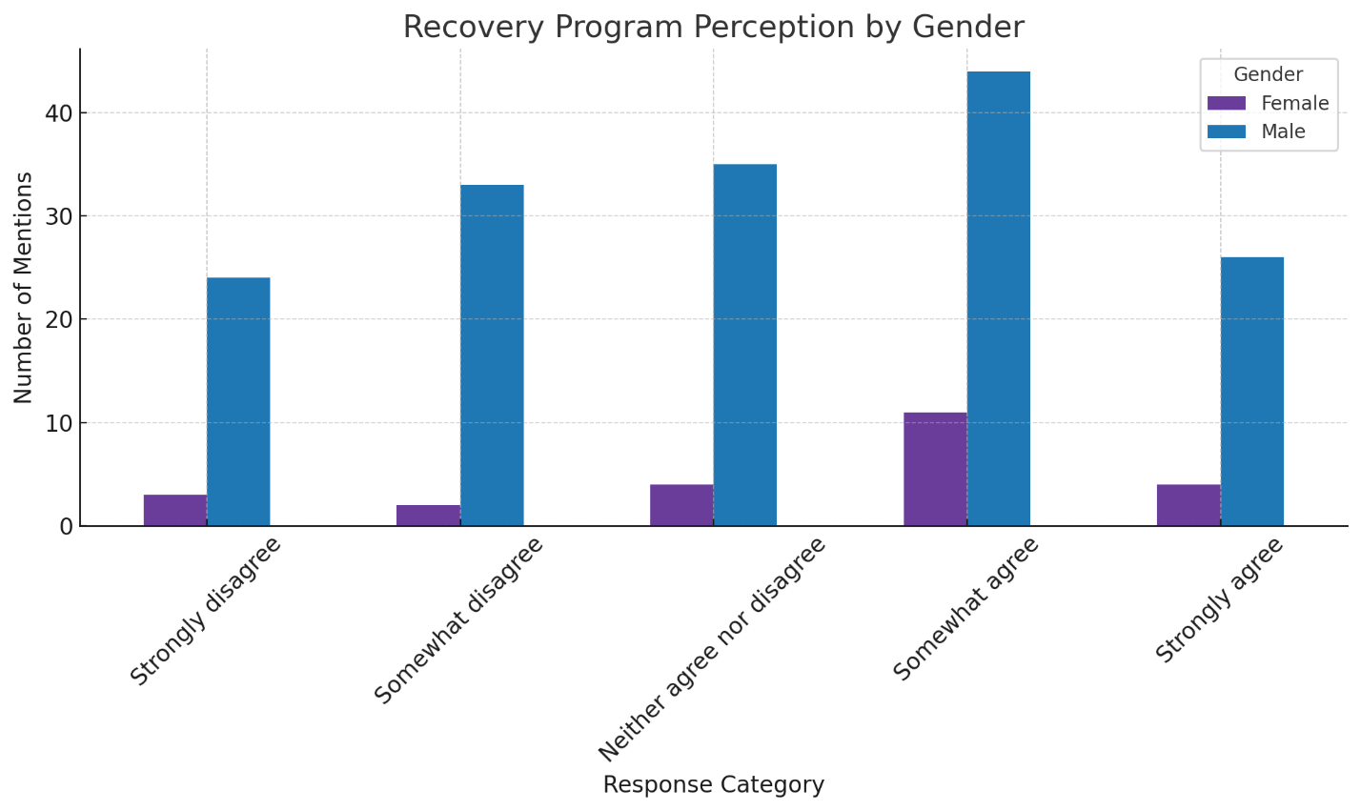

**Figure 3: Perceptions of Post-fire recovery programs by Gender**

*Bar chart showing responses to post-fire recovery and ecosystem restoration programs' adequacy, disaggregated by gender. Response categories range from “Strongly disagree” to “Strongly agree.” Male respondents were the majority across all categories, reflecting the survey sample's demographic composition rather than an opinion trend.*

Regional data suggest disparities in recovery perceptions, particularly in the Western Cape, where responses were mixed regarding the presence of support programs and restoration guidelines after damaging wildfires. In terms of gender, male respondents were more likely to "strongly disagree" about the effectiveness of recovery programs compared to females (see fig. 5c).

# Summary of Results

This assessment found mixed perceptions within each of the five R’s of IFM. Further analysis of demographic variables revealed multiple trends across race, gender, and province.

## Review

Most respondents perceived that wildland fires have significant unwanted effects in their communities. Respondents from the province of Western Cape expressed the most concern regarding the unwanted impacts of wildland fires. Demographically, Black respondents were particularly concerned about the unwanted effects of wildfires, which could reflect heightened awareness within this demographic. Gender based results showed that male respondents were more concerned about the unwanted effects of wildland fires compared to their female counterparts. This may suggest that males in the sample have had more direct encounters or negative experiences with wildfires.

## Risk Reduction

Assessment results indicated that when considering human originated wildfires, arson is identified as the leading cause followed by negligence. Respondents also identified other human originated causes related to grazing and fuel management. Demographically, gender-based results revealed female respondents to be particularly concerned by arson as a cause of intentionally set fires. This could indicate safety concerns or experiences that female respondents associate with intentionally set fires.

## Readiness

There were diverse perspectives regarding wildland fire personnel readiness in South Africa. For example, respondents had mixed perspectives depending on province on whether they had enough personnel to deal with wildland fires. Respondents from Western Cape province stood out as the most concerned regarding personnel readiness, which points to the importance of taking localized concerns into consideration.

## Response

Most respondents stated that an ICS is used in their community, which indicates that there is indeed a structured response mechanism in place. However, regional disparities showed that respondents from the province of Western Cape perceived a greater ability for response than respondents from provinces such as Eastern Cape and Gauteng, who showed mixed perceptions. Moreover, while most respondents believed that firefighters in South Africa are adequately equipped for response, several respondents expressed concern about the actual quality or availability of equipment. Meanwhile, female respondents were slightly more optimistic than male respondents about the provision of equipment to firefighters. This optimism may stem from fewer direct encounters with inadequacies or a general positive perception of local firefighting efforts.

## Recovery

Perceptions toward restoration guidelines for ecosystems affected by wildland fires were mixed. While most respondents felt there were adequate restoration guidelines in place, several respondents still cited having concerns. Meanwhile, regional data suggested potential disparities in recovery efforts. For instance, in the Western Cape province, perceptions were mixed regarding support programs and restoration guidelines after damaging wildfires. Demographically, male respondents were more likely to perceive that there were not effective recovery programs in place. This could indicate that males in the sample may have had more direct experiences with postfire landscape recovery efforts and found these efforts lacking.

In sum, assessment findings offered a detailed understanding of perceptions related to wildland fire management in South Africa. For example, the Western Cape is notably concerned about personnel readiness, response efficiency, and recovery efforts. Demographic analyses revealed differences between Black and White respondents, as well as significant gender-based differences regarding equipment provision and arson concerns. Despite a general acknowledgment of wildland fire challenges, regional and demographic disparities necessitate targeted fire management strategies that address specific vulnerabilities and perceptions across South Africa.

## Opportunities for Further Investigation

This assessment served as an initial attempt to capture the perspectives of wildland fire managers in South Africa using the framework of IFM. We suggest that additional qualitative research be conducted prior to administering this assessment to fire managers in other countries on the African continent. Results from this assessment can be used to develop qualitative focus groups with small groups (five-eight people) of wildland fire managers for more in-depth understanding of specific quantitative results. Focus groups, which are designed to focus on a singular topic, can be used to gain feedback on assessment questions and revise questions to improve the assessment. We suggest conducting a focus group for each of the five R’s of IFM. US Forest Service International Programs can work alongside South African wildland fire managers to develop a set of focus group questions (five-eight questions) around what they believe are the most significant results. Through the process of developing, administering, recording, analyzing, and reporting on focus group findings, new insights can be used to both revise assessment questions and perhaps establish new lines of inquiry that may not be represented in the current assessment. Another qualitative approach are in depth interviews, which are well designed and structured one on one conversations of approximately one hour that can be used to provide insight into the meaning behind responses and may open new ideas on how to approach IFM more deliberately across diverse South African provinces. Therefore, we suggest further revision of this assessment along with development of more in depth results through the use of social science qualitative methodologies.

## Assessment Limitations

Administration of this assessment consisted of snowball sampling beginning with South African fire managers working directly with US Forest Service International Programs. While part of the intent of the assessment was to capture diverse perspectives of wildland fire managers across South Africa, researchers were aware that survey responses would have a skewed gender, demographic, and spatial outcome that would lead to sample bias. As a result, the sample consisted of wildland fire managers who are predominantly male (86% of respondents), White (91% of respondents), and who work in the province of Western Cape (76% of respondents). The province of Western Cape has a summer wildfire season while the rest of the country’s fire season takes place during the winter. Moreover, the Western Cape response system has a broader focus on all hazard events including wildfire and therefore allocates more resources to mitigating risks to all hazards. Thus, although the assessment captured perspectives from provinces across South Africa, the provinces of Free State, Limpopo, and Northern Cape were significantly underrepresented in this assessment. The perspectives of female and non-White (Black, Coloured, or other race) respondents were also significantly underrepresented.

# Conclusion

This assessment captured the perspectives of South African wildland fire managers with the intent to better understand the context of wildland fire management in South Africa, as well as to uncover the knowledge gaps and resource needs of wildfire managers across the country. The assessment draws upon the wildland fire management framework of the five R’s of Integrated Fire Management (IFM): review, risk reduction, readiness, response, and recovery of wildfires (Moore 2019). The development, administration, analysis, and results of this assessment within the five R’s of the IFM framework begin with the bottom up perspectives of wildland fire managers directly engaged in fire management rather than beginning from a top down perspective of testing a policy or applying a theoretical lens from the literature on the human dimensions of wildland fire. For example, respondents from the South African province of Western Cape indicated the most concern about the harmful effects of wildfire on their communities, specifically loss of life. In addition, respondents who identified as Black expressed the greatest concern about the negative impacts of wildland fire, while male respondents were more likely than female respondents to express greater concern. Thus, the results from this assessment also suggest the importance of moving away from a one size fits all approach to IFM across South Africa, and instead, toward applying an approach that is sensitive to local perspectives at each point of the five R’s of IFM.

# References

Dombeck, Michael P.; Williams, Jack E.; Wood, Christopher A.; 2004. Wildfire policy and public lands: Integrating scientific understanding with social concerns across landscapes. Conservation Biology. 18(4): 883-889.

Flores, David; Fox, Rebekah L.; Jahn, Jody; [et al.]. 2024. Using focus groups for knowledge sharing: Tracking emerging pandemic impacts on USFS wildland fire operations. Society and Natural Resources. 37(6): 957-975. <https://doi.org/10.1080/08941920.2024.2341271>.

Jolly, W. Matt; Cochrane, Mark A.; Freeborn, Patrick H.; [et al.]. 2015. Climate-induced variations in global wildfire danger from 1979 to 2013. Nature Communications. 6: 7537.

Jones, Matthew W.; Abatzoglou, John T.; Veraverbeke, Sander; [et al.]. 2022. Global and regional trends and drivers of fire under climate change. Reviews of Geophysics. 60(3): e2020RG000726. <https://doi.org/10.1029/2020RG000726>.

Lambrechts, Hugo A.; Paparrizos, Spyridon; Brongersma, Robijn; [et al.]. 2023. Governing wildfire in a global change context: Lessons from water management in the Netherlands. Fire Ecology. 19(1): 6.

Lin, Zhengyang; Chen, Anping; Wang, Xuhu; [et al.]. 2024. Large language models reveal big disparities in current wildfire research. Communications Earth and Environment. 5(1): 168.

Moore, Peter F. 2019. Global wildland fire management research needs. Current Forestry Reports. 5: 210-225.

Rego, Francisco C.; Morgan, Penelope; Fernandes, Paulo; [et al.]. 2021. Integrated fire management. In: Rego, Francisco C.; Morgan, Penelope; Fernandez, Paulo, eds. Fire science: From chemistry to landscape management. Iowa City, IA: Prairie Light Books: 509-597.

van Wilgen, Brian W.; Govender, Navashni; Smit, Izak P. J.; [et al.]. 2014. The ongoing development of a pragmatic and adaptive fire management policy in a large African savanna protected area. Journal of Environmental Management. 132: 358–368. [https://doi.org/10.1016/j.jenvman. 2013.11.003](https://doi.org/10.1016/j.jenvman.%202013.11.003).

Wollstein, Katherine; Creutzburg, Megan K.; Dunn, Christopher; [et al]. 2022. Toward integrated fire management to promote ecosystem resilience. Rangelands. 44(3): 227-234. <https://doi.org/10.1016/j.rala.2022.01.001>.